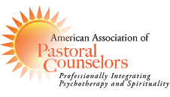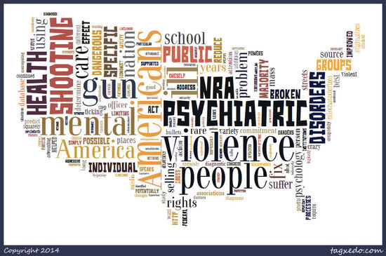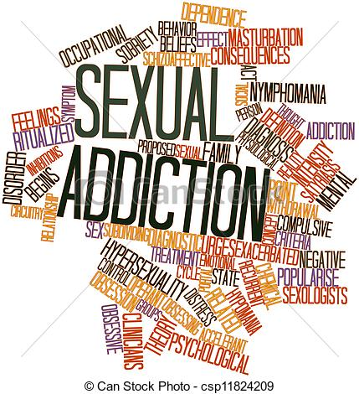 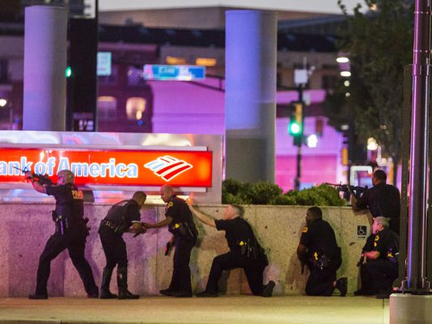

**Partnering Institutions:**

Denver Seminary

Eremos Consulting Group

The Iliff School of Theology’s Department of Spiritual & Pastoral Care

Pastoral Counseling Center of Dallas

The Upper Room Academy for Spiritual Formation

Register Faster and Easier ONLINE at

[Conference Registration Page](http://events.r20.constantcontact.com/register/event?llr=phmn98cab&oeidk=a07ecv4aga25699a520)

*or go to*

www.AAPC.org

1. Click on Regions
2. Then click on

WEST Region

1. Open Conference Link and register for conference

Name: ________________________________________________

Business/School: _______________________________________

Address: ______________________________________________

City: _________________________________________________

State & Zip: ___________________________________________

Email: ________________________________________________

Phone: _______________________________________________

Credit Card # __________________________________________

Exp Date _______ CVC Code ______ Billing zip code ___________

☐ **General Pre-Registration –**  (check city)

**Dallas** ☐  **or Denver** ☐ **$129**

Includes refreshments and lunch and CEUs

☐ **AAPC Members - Pre-registration** (check city)

**Dallas** ☐ **or Denver** ☐ **$ 99**

Includes refreshments and lunch and CEUs

☐ **Student Fee Dallas** ☐  **or Denver** ☐ **$ 69**

Includes refreshments and lunch

☐ **Denver Seminary Faculty & Staff** $ **69**

**☐ *Register at the door - Dallas ☐ or Denver ☐* Add $10**

**Total Due $____________**

**Pre-registration Deadline: Friday, Nov. 4, 2016**

*Register online OR cut out and return form with check to:*

AAPC-West Conference

c/o Dr. David DeBord

878 South 14th Avenue

Brighton, CO 80601

A Spiritual Care Conference for

Spiritual Caregivers, Clergy, Chaplains & Counselors

**November 12, 2016**

**AAPC West Region Presents:**

**Two Community Crises:**

**Two Pastoral Care Responses**

*Two Keynote Speakers*:

**Connie Lofgreen, MSW, CSAT**

“Responding to Sex and iPorn Addiction”

**Dr. Brad Schwall**

“Responding to Trauma after Dallas shootings”

*TWO SIMULTANEOUS LOCATIONS\**

***8am to 4pm IN DENVER***

**Hosted by Denver Seminary**

6399 South Santa Fe Dr.

Littleton, CO 80120

***9am to 5pm IN DALLAS***

**Hosted by Pastoral Counseling Center**

4525 Lemmon Ave #200,

Dallas, TX 75219

### Registration Form – Nov. 12, 2016

8 am Registration opens

8:30 am Welcome

9:00 am Morning Presentation (Denver)

Connie Lofgreen, MSW, CSAT

*“The Leader’s Guide to Responding to Sex and iPorn Addiction” – Part I*

10:15 am Break

10:30 am Connie Lofgreen – Part II

11:30 am Lunch (included in registration)

12:30 pm Afternoon Presentation (Dallas)

Dr. Brad Schwall – Part I

“Responding to Trauma”

1:45 pm Break

2:00 pm Dr. Schwall and PCC Staff – Part II

“Beyond Crisis – The Mental Health Conversation”

3:00 pm Time for Integration

3:30 pm AAPC West Regional Meeting

4:00 pm Adjourn

Sat., November 12, 2016

At Pastoral Counseling Center, Dallas, TX

9am to 5pm central time

9 am Registration opens

9:30 am Welcome

10:00 am Morning Presentation (Denver)

Connie Lofgreen, MSW, CSAT

*“The Leader’s Guide to Responding to Sex and iPorn Addiction” – Part I*

11:15 am Break

11:30 am Connie Lofgreen – Part II

12:30 pm Lunch (included in registration)

1:30 pm Afternoon Presentation (Dallas)

Dr. Brad Schwall – Part I

“Responding to Trauma”

2:45 pm Break

3:00 pm Dr. Schwall and PCC Staff – Part II

“Beyond Crisis – The Mental Health Conversation”

4:00 pm Time for Integration

4:30 pm AAPC West Regional Meeting

5:00 pm Adjourn

Sat., November 12, 2016

At Denver Seminary, Littleton, CO

8am to 4pm mountain time

***We have a unique opportunity this year*** *to bring together people from across the newly formed West Region of AAPC. We will have a keynote speaker in Denver and one in Dallas, and their two presentations will be streamed live to both locations so that attendees in both locations will have face-to-face access as well as virtual access to the speakers. This is an opportunity for members, friends, and colleagues from across disciplines and across the region to come together and connect.*

***Register NOW for this special event!***

**Two Community Crises: Two Responses**

November 12, 2016 – AAPC WEST Region Fall Conference

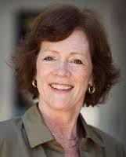

**Connie Lofgreen, MSW, CSAT**

*“The Leader’s Guide To Responding to Sex and iPorn Addiction”*

*Sex addiction and iPorn addiction are prevalent within our communities, having become a public health epidemic. In these presentations Lofgreen will give an overview of the signs and definitions, the factors that increase vulnerability, the impact on partners, as well as tools for helping with shame and empowering clients for success in recovery. We will learn about the unique vulnerability of clergy and other helping professionals, and will come away with strategic initiatives for addressing this addiction.*

Connie Lofgreen is a Marriage and Family Therapist and a Certified Sex Addiction Therapist in private practice in Omaha, Nebraska. She is the creator of STARPRO (Sexual Treatment and Recovery Program) – a specialized treatment program for sex addicts, their partners and families. She is the author of *The Storm of Sex Addiction: Rescue and Recovery* which has received praise from Mary Pipher (*Reviving Ophelia)*, Charlotte Sophia Kasi *(Women, Sex and Addiction)*, and Brenda Schaeffer *(Is It Love or Is It Addiction?).*

Lofgreen has over 30 years of successful relationship and trauma counseling experience, including extensive work with adult survivors of childhood sexual abuse. She is an organizational consultant and trainer in clergy sexual ethics, a certified EMDR practitioner, and a specialist in conducting group therapy. Lofgreen received a degree in Sociology from Kansas State University and her Master’s Degree in Social Work from Rutgers University.

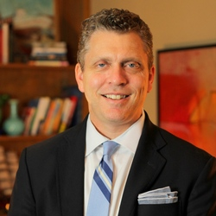

**Brad Schwall, D. Min**

Executive Director

Pastoral Counseling Center, Dallas, TX

*“Responding to Trauma & Beyond Crisis”*

*Following the police shootings in Dallas, PCC was one of the responder agencies. But this role came because of a series of community connections that had been built over the past few years. In these presentations, PCC staff will join with Dr. Schwall to discuss their understanding, response, and background work that led to their being a resource when the crisis came.*

Dr. Schwall has been providing counseling, leading social and emotional skills classes for children, training youth professionals, counselors, and educators, and facilitating parenting workshops for over 20 years.  He has experience training the staff of major social service and educational organizations as well as experience writing and being interviewed for news programs on parenting and childhood issues.  He created Cool Kids, a social and emotional learning program for schools.  The Cool Kids curriculum has been used by public and private schools across Texas as well as outside of Texas. Dr. Schwall has his school counselor and principal certification, and his educational background includes a bachelor’s degree in education from Baylor University and a doctorate in pastoral psychotherapy from Garrett Theological Seminary at Northwestern University in Evanston, Illinois.

 For Almost 50 years, the Pastoral Counseling Center (PCC) has been a trusted resource helping families navigate life’s changes and challenges through counseling and psychological services for children, teens, and adults in North Texas.

## About our Presenters

# Conference Schedule